Machine learning approach for rainfall prediction

done by group SPSGP-593759

1. INTRODUCTION

1.1 Project Overview

Our project uses a Flask-deployed RandomForest machine learning model to provide predictions via an easy-to-use website. This model makes precise predictions by using past data. Users of the website can enter pertinent data and get forecasts in real time.

1.2 Purpose

The main aim of the program is to develop a robust and effective rainfall forecasting model that can help predict rainfall levels based on weather patterns. The model was designed to address climate change and assist in agricultural decision-making, water management and disaster preparedness.

2. LITERATURE SURVEY

2.1 Existing problem

A meticulous examination of extant challenges and methodologies in the domain of rainfall prediction, scrutinizing prevailing paradigms and identifying intricacies inherent in the process.

2.2 References

1] Thirumalai, Chandrasegar, et al. "Heuristic prediction of rainfall using machine learning techniques."2017 International Conference on Trends in Electronics and Informatics (ICEI). IEEE, 2017.

[2] Geetha,  A., and  G. M. Nasira.  "Data mining  for meteorological  applications: Decision  trees  for modeling rainfall prediction." 2014 IEEE International Conference on Computational Intelligence and Computing Research.

2.3 Problem Statement Definition

Creating a web application that uses a machine learning model trained using the RandomForest algorithm is the stated problem. Through a website, users should be able to enter pertinent data into this programme and receive predictions pertaining to the issue the model attempts to solve. In order to make the model a useful tool for decision-making and problem-solving in a particular domain, the primary goals are to provide an intuitive user interface, guarantee the model's smooth integration with Flask, and provide precise and timely forecasts.

3. IDEATION & PROPOSED SOLUTION

3.1 Empathy Map Canvas

A nuanced exploration of user and stakeholder perspectives, encapsulated in an Empathy Map Canvas, facilitating a profound comprehension of end-user needs.

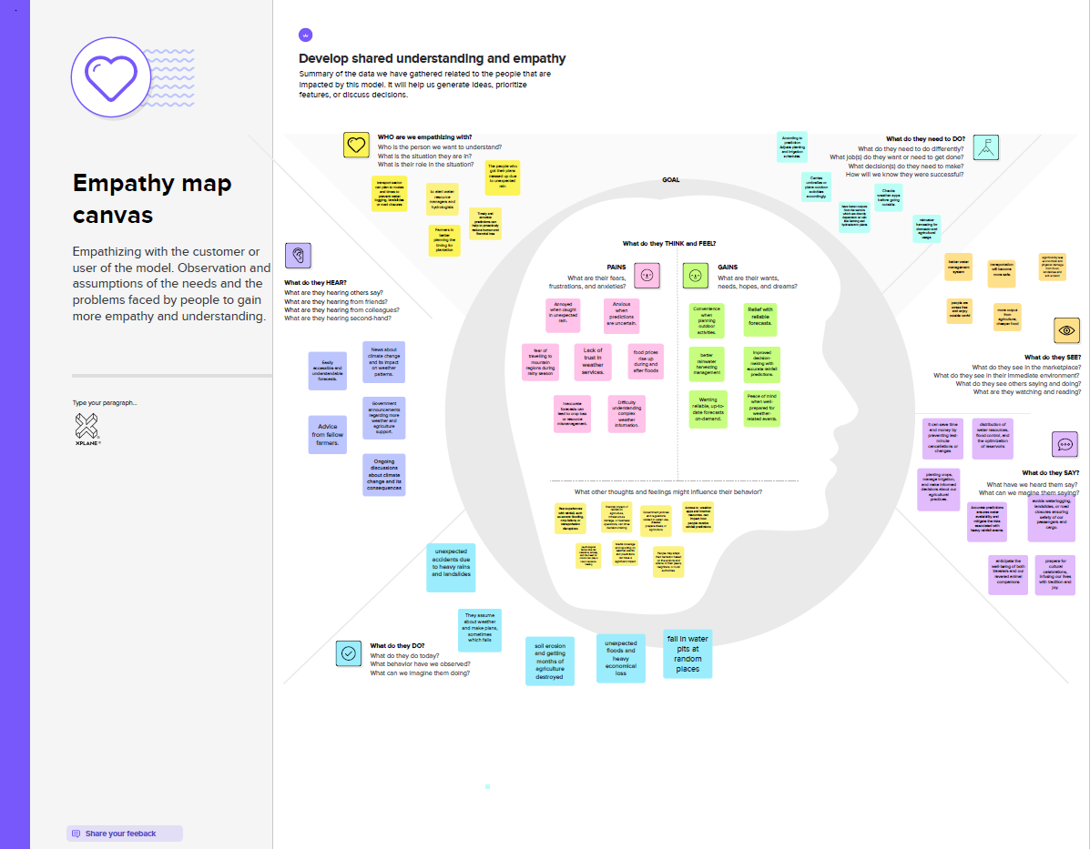

3.2 Ideation & Brainstorming

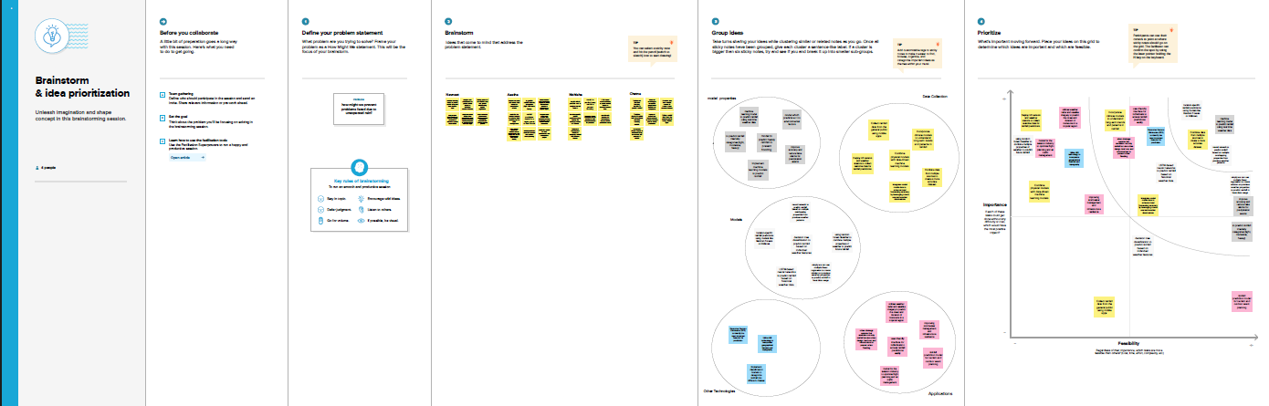

4. REQUIREMENT ANALYSIS

4.1 Functional requirement

A detailed breakdown of operational needs, highlighting specific features and operational needs through machine learning-driven rainfall prediction models.

1. Describe what the product does:

   - The product employs the Random Forest algorithm to forecast rainfall levels based on meteorological data, aiding in climate adaptation, informed agriculture, water management, and disaster preparedness.

2. Define product features:

   - Features include data preprocessing, user-friendly input interface, Random Forest algorithm implementation, and the consideration of key meteorological parameters for accurate predictions.

3. Focus on user requirements:

   - Users, such as farmers and disaster response teams, require a straightforward interface to input meteorological data and obtain timely, reliable rainfall predictions for informed decision-making.

4. Captured in use case:

   - Use cases outline scenarios where users input data, the system processes it with the Random Forest algorithm, and accurate rainfall predictions are presented, ensuring diverse user needs are met.

5. They are mandatory:

   - Accuracy in rainfall predictions, effectiveness of the Random Forest algorithm, and a user-friendly interface are essential for achieving the project's objectives.

6. Usually defined by user:

   - User requirements derive from the needs and expectations of end-users, shaping the functionality and features of the product.

7. Components, API, UI testing, etc., tested before non-functional testing:

   - The testing sequence begins with individual component, API, and UI testing, ensuring fundamental functionalities work before progressing to non-functional testing (performance, security, usability).

8. External interface, authentication, authorization level, business rules:

   - Testing encompasses scrutiny of external interfaces, secure access via authentication and authorization levels, and validation of business rules governing the machine learning algorithm for accurate predictions.

4.2 Non-Functional requirements

The guidelines precisely define the fault characteristics of the system, including performance standards, availability standards, and safety indicators.

1. Describe how the product works:

   - The product functions by processing input meteorological data through the Random Forest algorithm, utilizing data preprocessing techniques, and presenting accurate rainfall predictions via a user-friendly interface.

2. Define product properties:

   - Properties include efficient data processing, algorithmic accuracy, user-friendly design, and the ability to handle diverse meteorological parameters for comprehensive rainfall predictions.

3. Focus on user expectations:

   - Users expect a seamless interface for inputting data, swift and accurate predictions, and an intuitive system that aids decision-making in agriculture, water management, and disaster preparedness.

4. Captured as a quality attribute:

   - Quality attributes encompass aspects like usability, reliability, scalability, and performance, which contribute to the overall excellence of the product.

5. They are not mandatory, but desirable:

   - While not mandatory, these attributes are highly desirable as they enhance the product's overall quality and user experience.

6. Usually defined by developers or other tech experts:

   - Developers and tech experts define these attributes based on technical considerations, ensuring the product meets high standards in terms of performance, reliability, and usability.

7. Performance, usability, security testing, etc., tested after functionality testing:

   - After functionality testing, the focus shifts to performance, usability, security testing, and other quality attributes to ensure the holistic excellence of the product.

8. Usability, reliability, scalability, performance, etc.

   - The product is assessed for usability, reliability, scalability, and performance, aligning with the defined quality attributes to ensure optimal functionality and user satisfaction.

5. PROJECT DESIGN

5.1 Data Flow Diagrams & User Stories

Visualization of the data flow in the system and descriptive encapsulation of the user interface provides a holistic view of the functional architecture of the project.

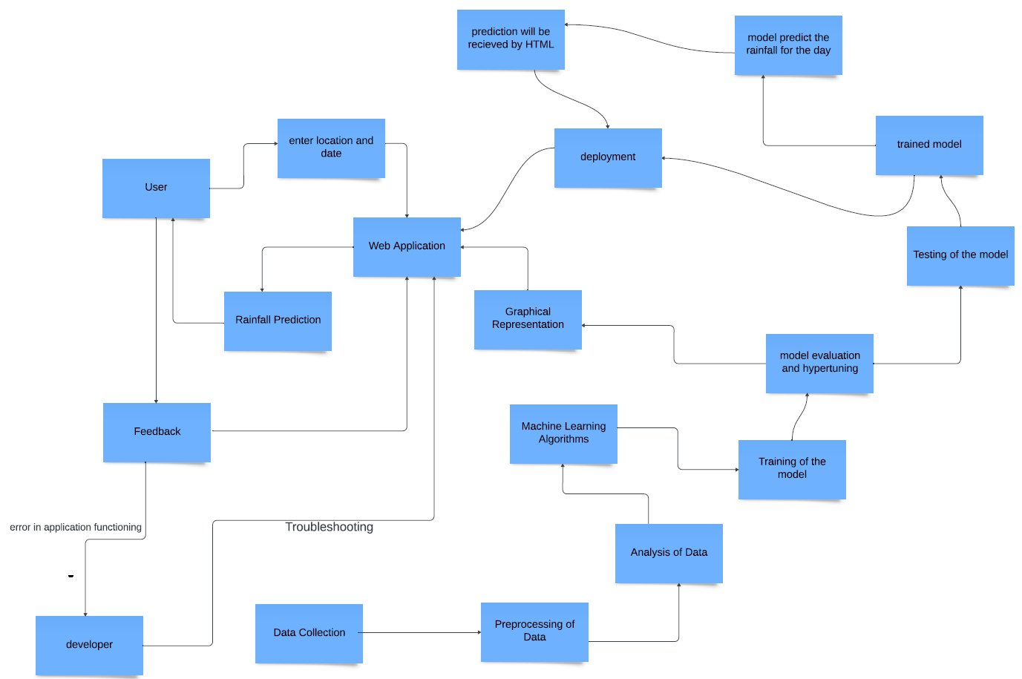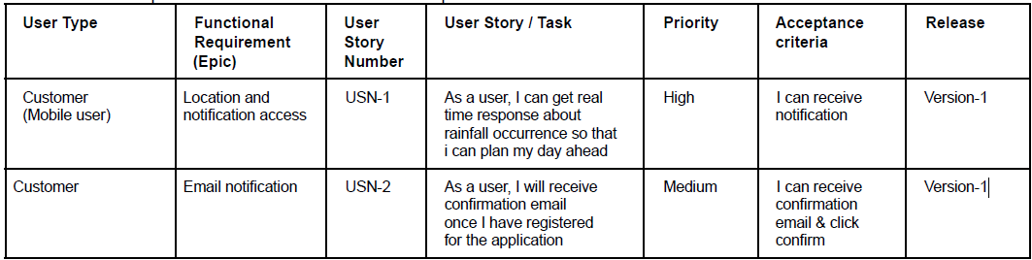

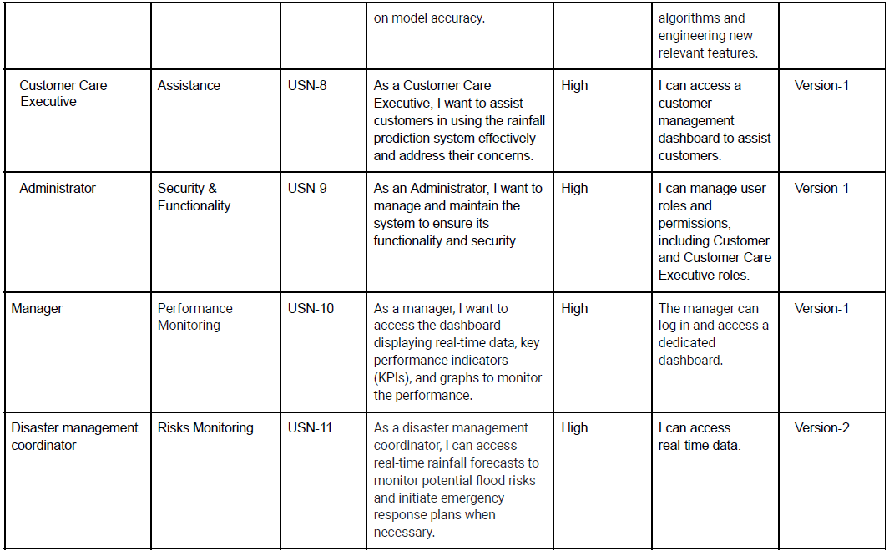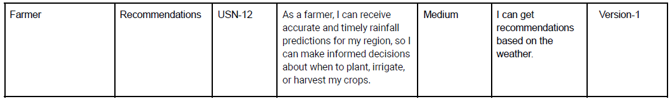

5.2 Solution Architecture

An architectural exposition delineating the structural composition and interaction dynamics of the rainfall prediction model, elucidating the integration of components within the system.

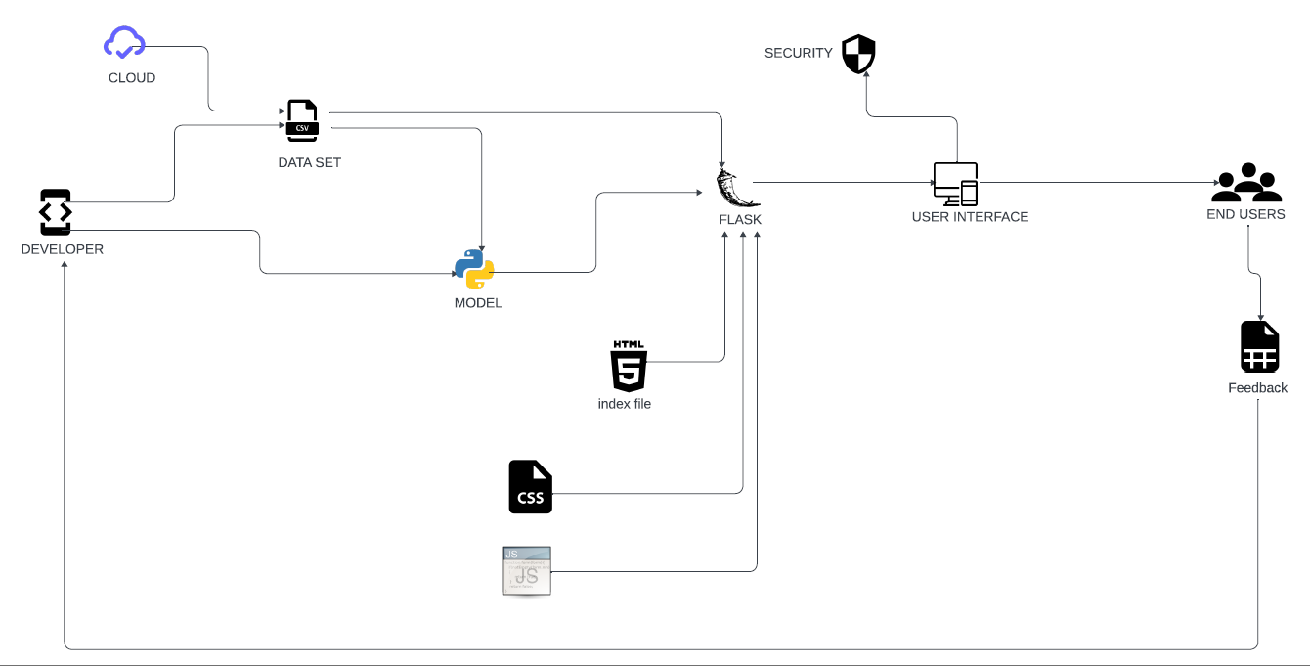

6. PROJECT PLANNING & SCHEDULING

6.1 Technical Architecture

A comprehensive description of the design process for managing complex project implementations, including physical components, interactions, and distribution considerations.

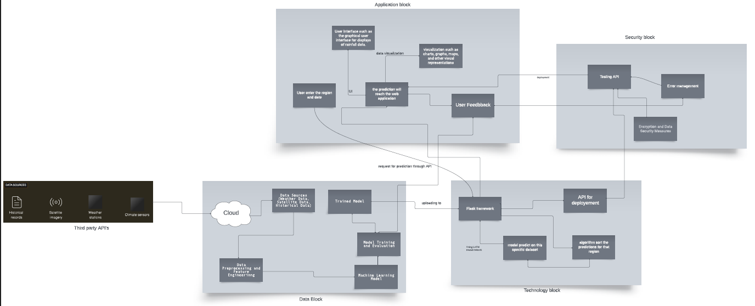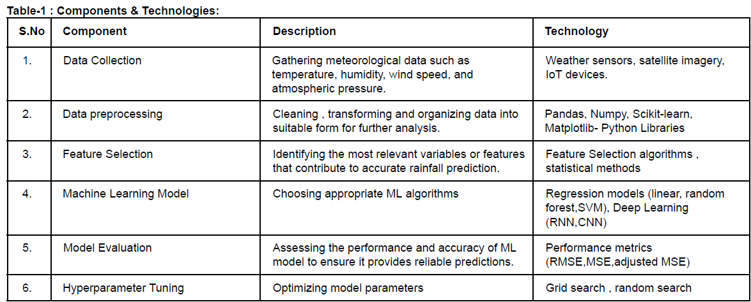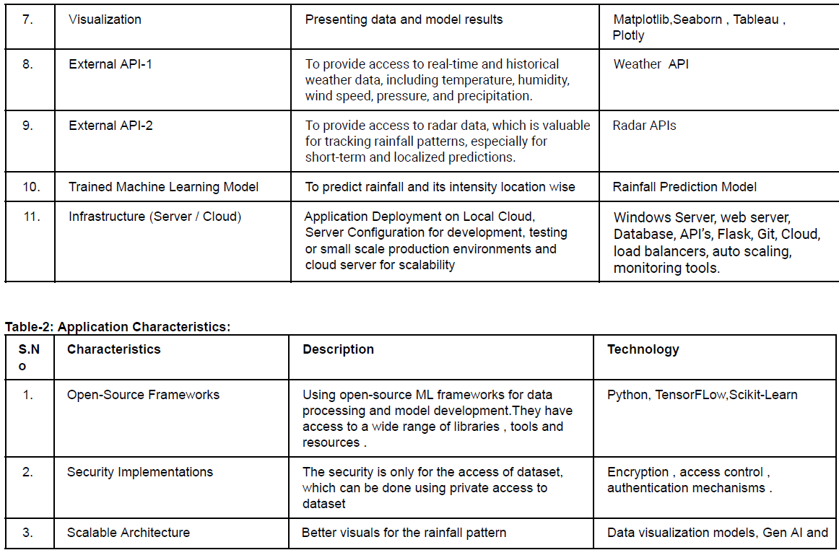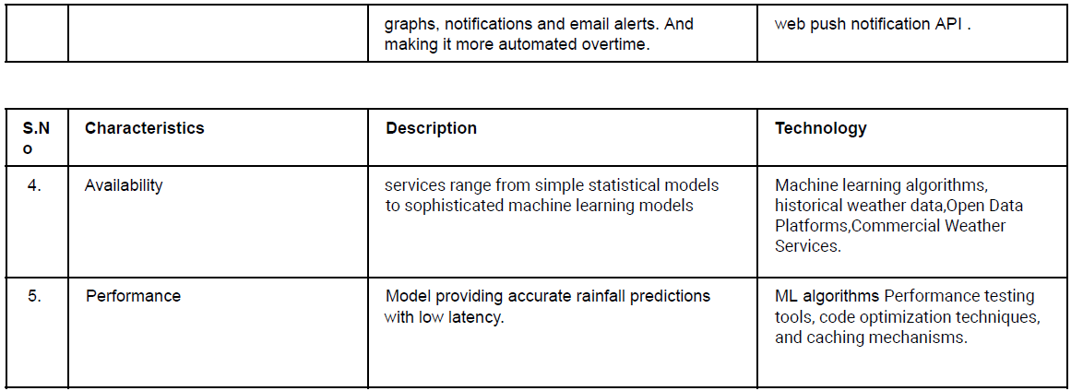

6.2 Sprint Planning & Estimation

Systematic decomposition of projects into managed sprints, combined with careful planning and estimation of each iteration, enables incremental improvement.

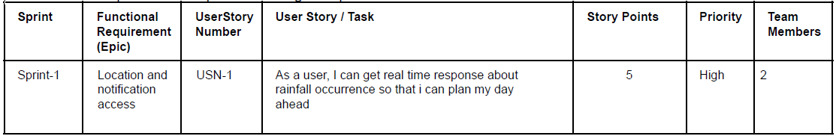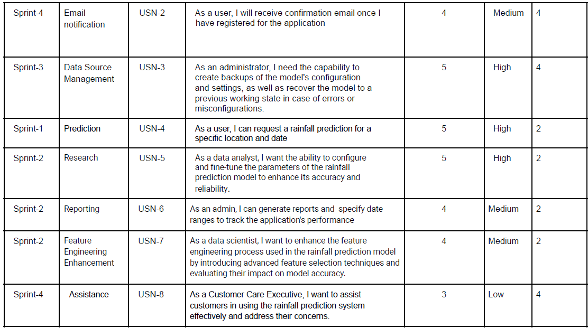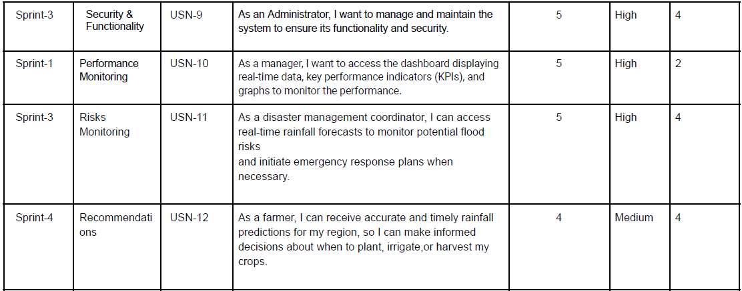

6.3 Sprint Delivery Schedule

A detailed schedule outlining the planned delivery of incremental project components after the conclusion of each sprint, promoting an agile and iterative development approach.



7. CODING & SOLUTIONING (Explain the features added in the project along with code)

7.1 Feature 1

Seasonal Features:To account for seasonal variations in rainfall, we have add features like month and day of the week.

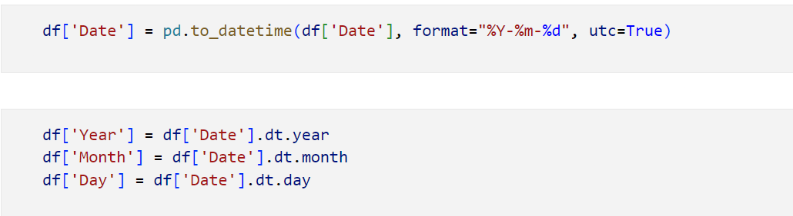

7.2 Feature 2

Weather-Related Features:

Incorporate additional meteorological data that might impact rainfall.



8. PERFORMANCE TESTING

8.1 Performance Metrics

Establishment and application of rigorous metrics to systematically evaluate the performance of the rainfall prediction model, ensuring precision and efficiency.

The performance metrics used here are:

Accuracy, Precision, Recall, F1- Score, Roc curve, Mean absolute error, mean square error, root mean squared error and K-fold cross validation(r2 score and mean r2 score)

9. RESULTS

Accuracy: 85.56%

Precision:0.76

Recall:0.5

F1- Score:0.60

Roc curve: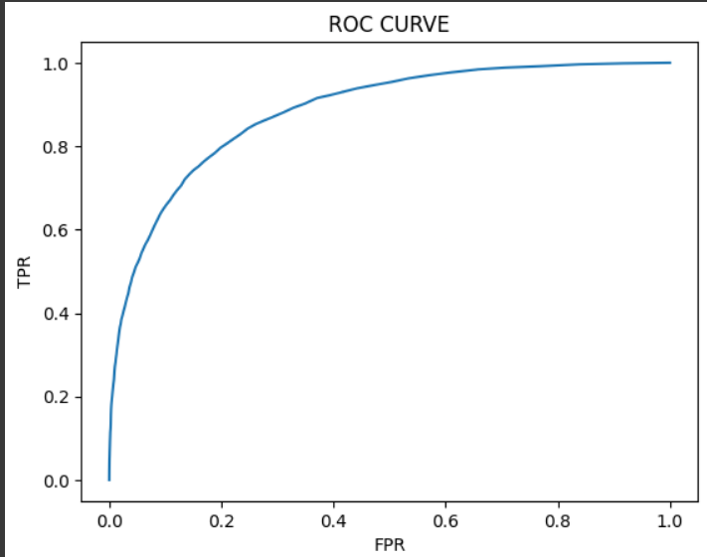

Mean absolute error: 0.144

Mean square error: 0.144

Root mean square error: 0.38

R2 score: [0.1592249  0.14750256 0.16325331 0.15641467 0.1550137 ]

Mean r2 score: 0.156

Sprint burndown chart:

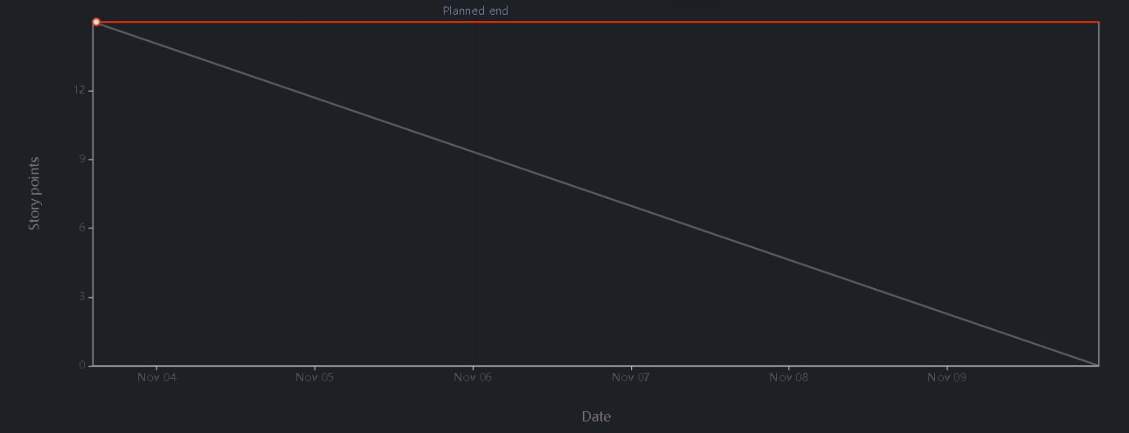

9.1 Output Screenshots

Visualization of output generated by the rainfall prediction model, substantiating its utility and reliability through tangible visual representations.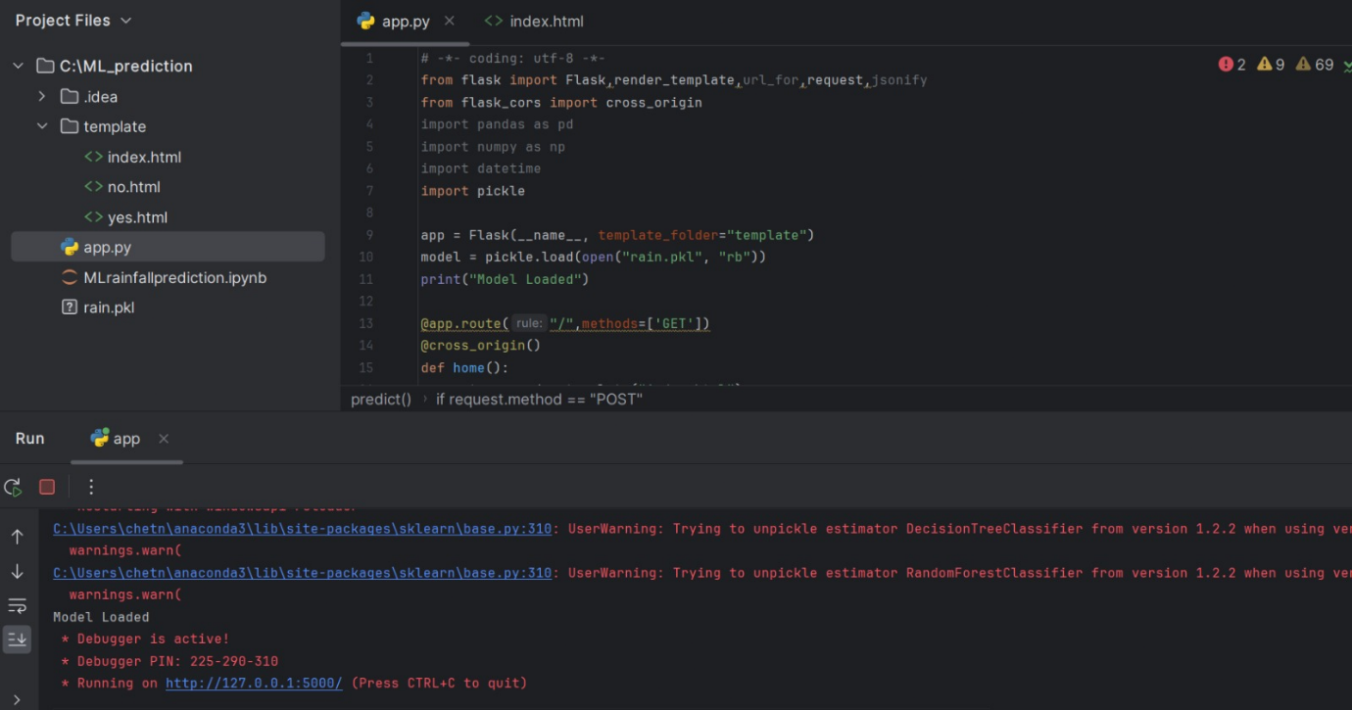

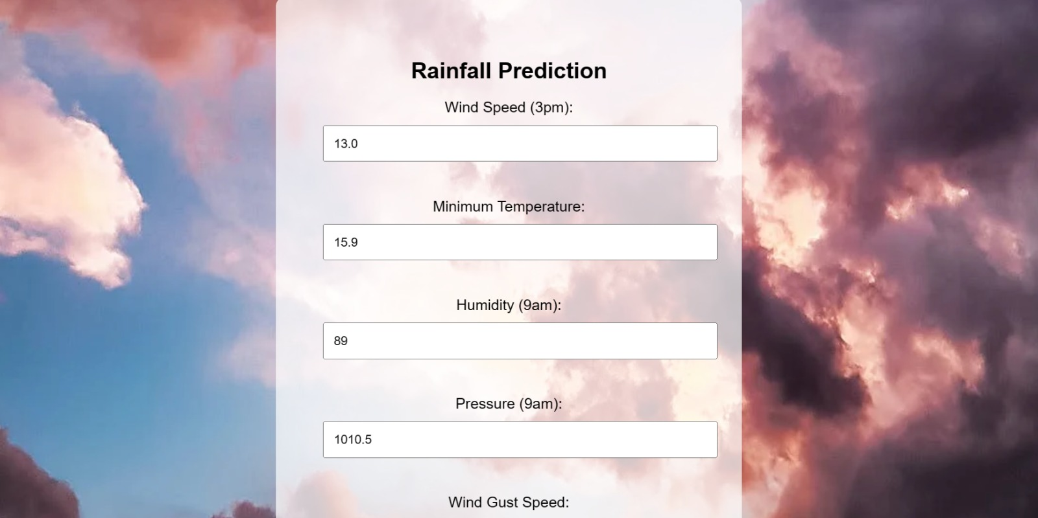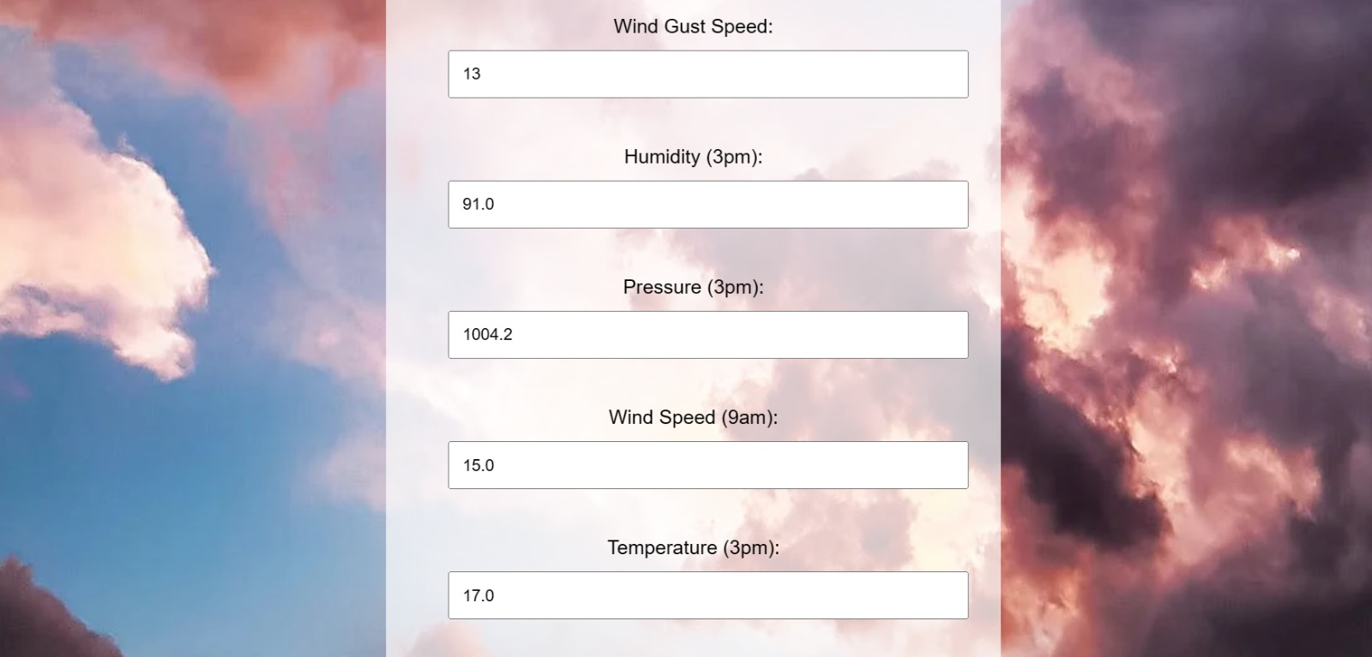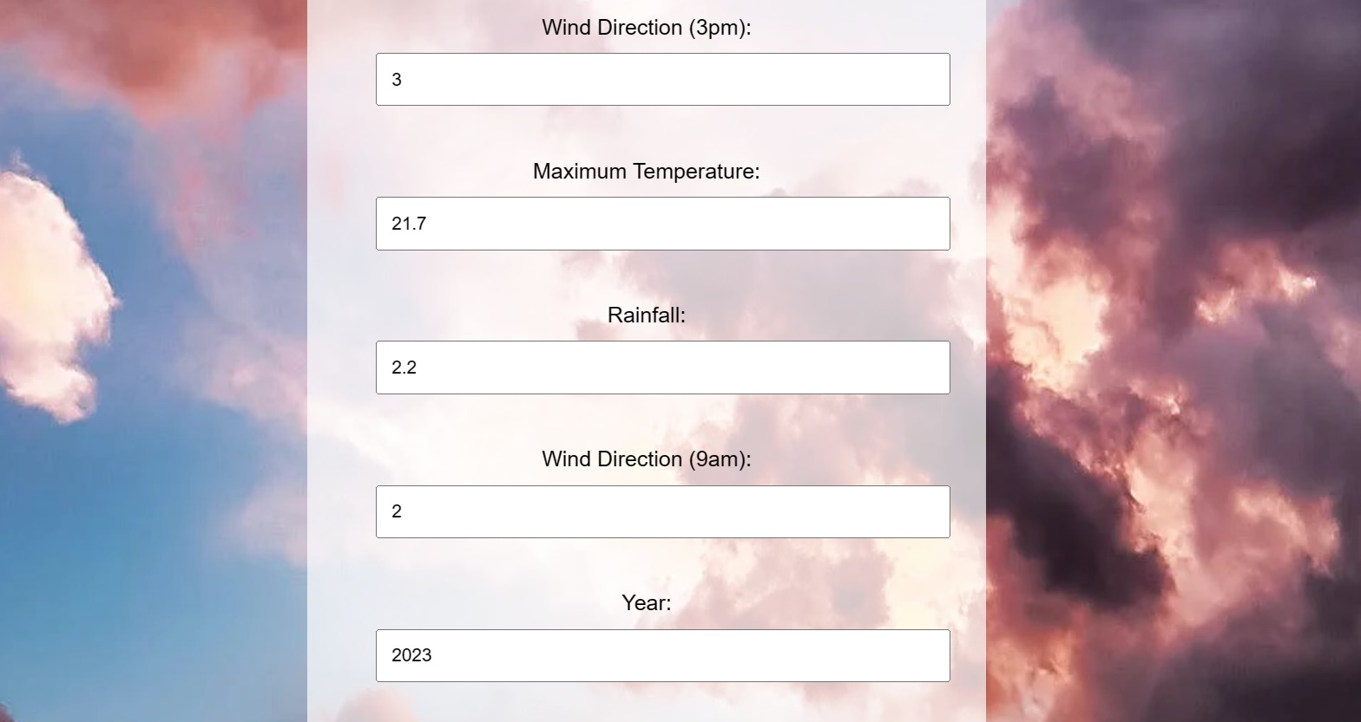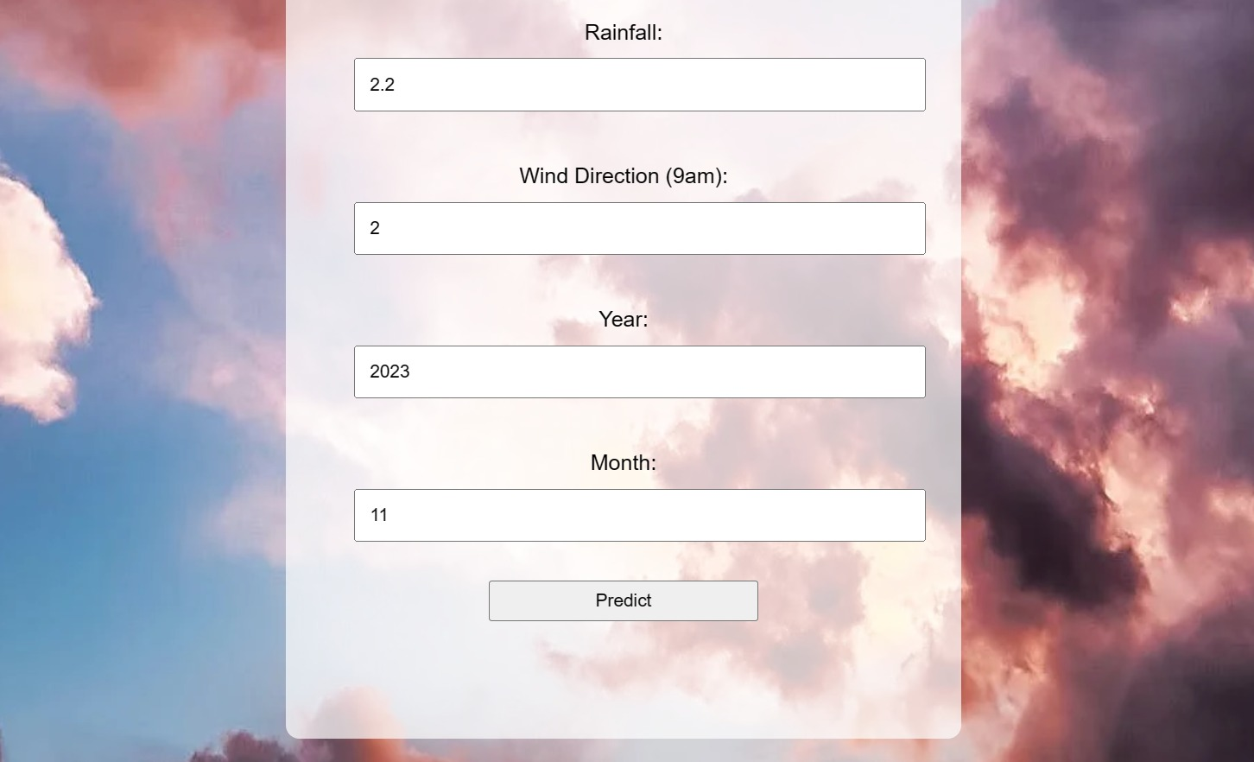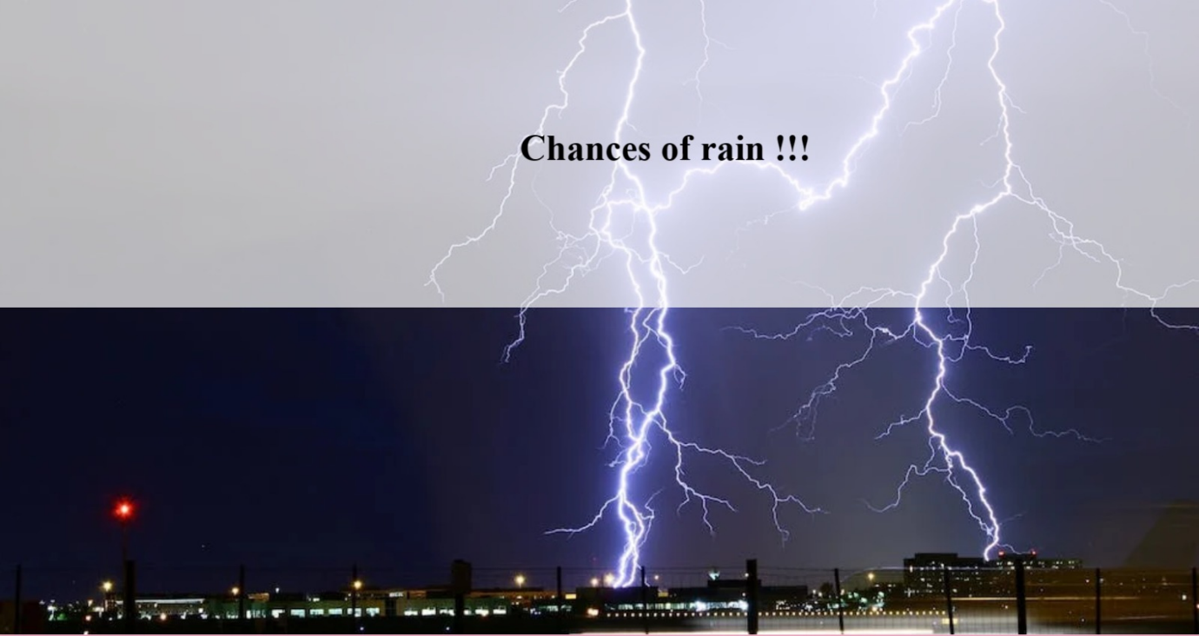

Alternate option



10. ADVANTAGES & DISADVANTAGES

Advantages :

1. Agricultural Planning
2. Water Resource Management
3. Disaster Preparedness
4. Personal Planning

Disadvantages:

1. False Alarms and Misses
2. Overreliance on Technology
3. Environmental Impact: In some cases, weather modification techniques based on rainfall predictions, like cloud seeding, may have unintended environmental consequences.

11. CONCLUSION

In conclusion, rainfall prediction is a critical component of weather forecasting and has wide-ranging impacts on various aspects of society, including agriculture, water resource management, disaster preparedness, infrastructure planning, and personal decision-making. It provides valuable insights into the future state of the atmosphere, allowing individuals and organizations to plan and respond to weather-related events.

12. FUTURE SCOPE

Advances in computing power and modeling techniques are enabling more accurate and higher-resolution rainfall predictions. Future research will focus on enhancing the resolution of predictions to provide more localized and accurate forecasts. This is particularly important for disaster preparedness and water resource management.This will lead to more accurate and timely forecasts, helping society better prepare for and respond to varying rainfall patterns and associated risks, including floods and droughts.

13. APPENDIX

[Rainfall Dataset of India | IEEE DataPort (ieee-dataport.org)](https://ieee-dataport.org/documents/rainfall-dataset-india)

This appendix explains and details the equivalences of the units used by some weather predictors in the International System of Units (SI).For atmospheric pressures (*Ps*, *Pa*, SLP), it is common to obtain data in millibar units, which, according to the IAU (International Astronomical Union), although in continuous use, is obsolete. The SI unit for pressure is the pascal (Pa), equal to one newton per square meter (N/m2).

Equivalence between bar and Pascal:

1 bar = 100,000 Pa = 100,000 N/m2

1 mb = 1 × 10−3 bar

1 mb = 1 hPa = 100 Pa

Geopotential height (*GPH*) is a vertical coordinate referring to the mean level of the Earth’s sea whose units are meters and explains the variation of gravity with latitude and altitude. In meteorology, it is used to express the height at which a given atmospheric pressure (hPa) is found. A geopotential height chart for a single pressure level in the atmosphere shows the troughs and ridges (highs and lows), which can be seen in the weather charts.

Source Code

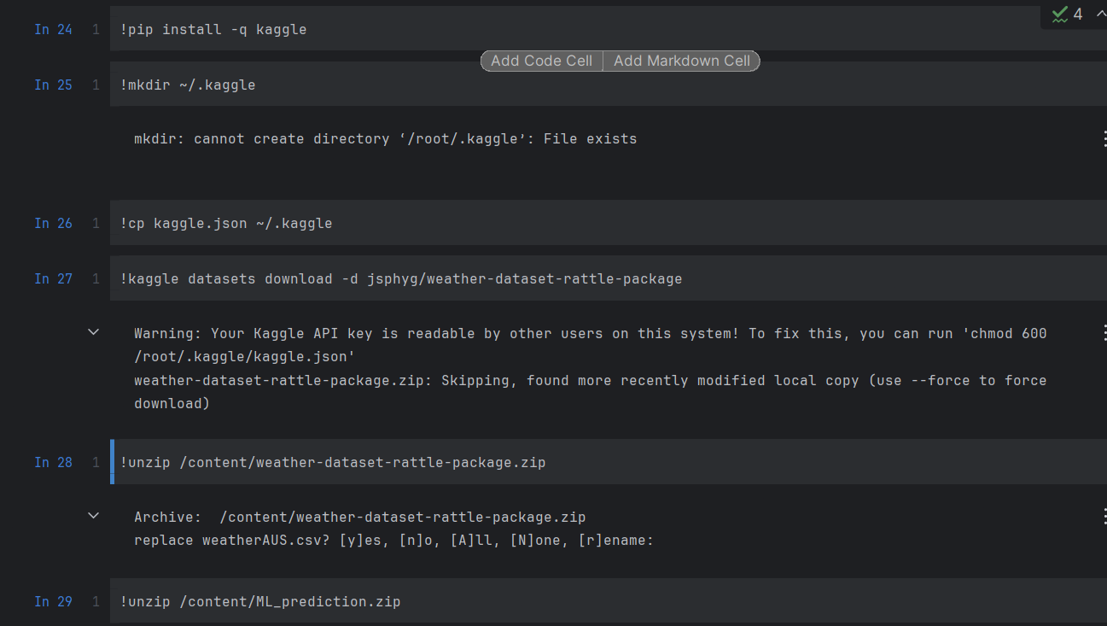

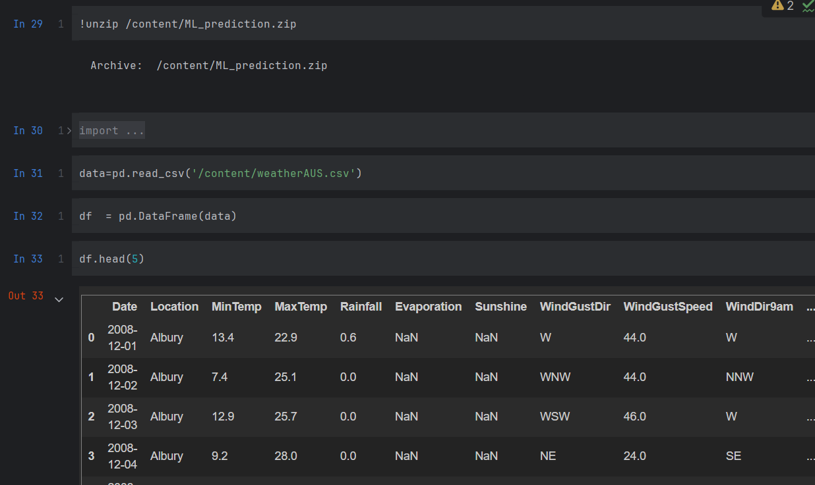

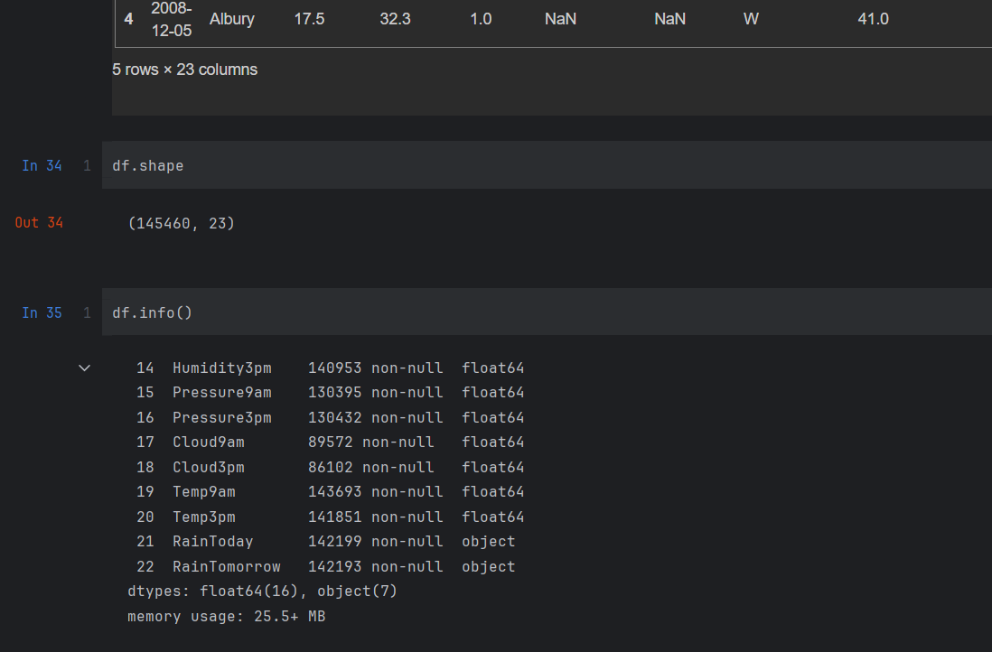

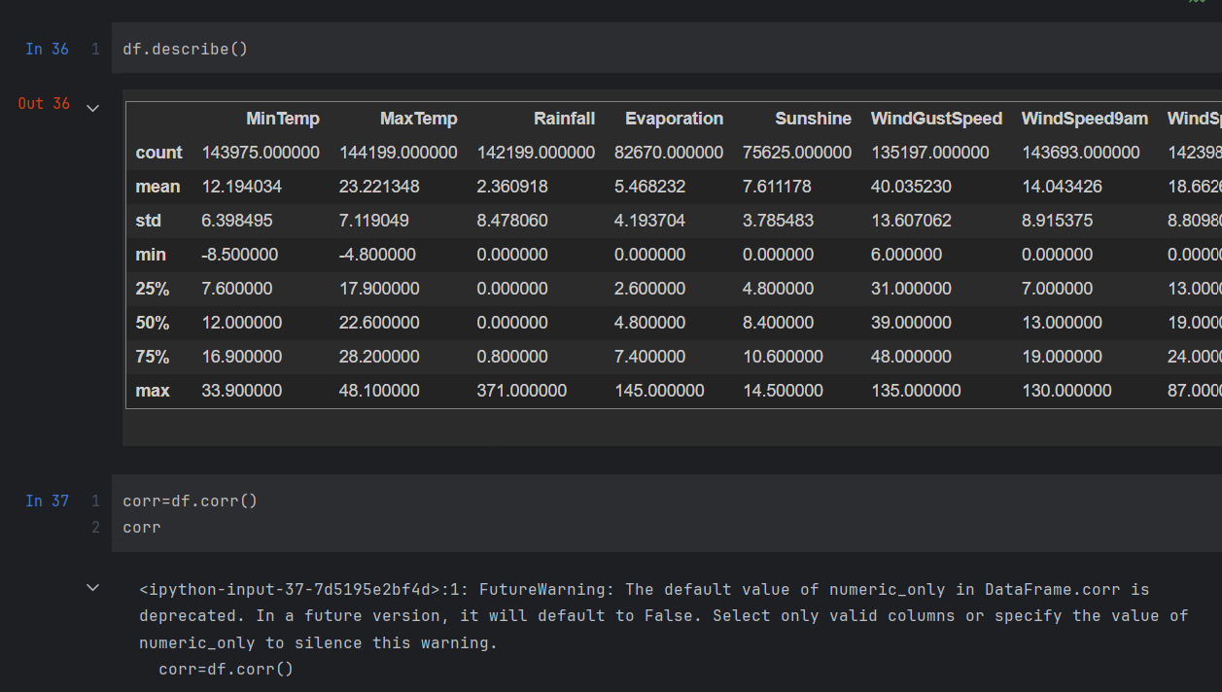

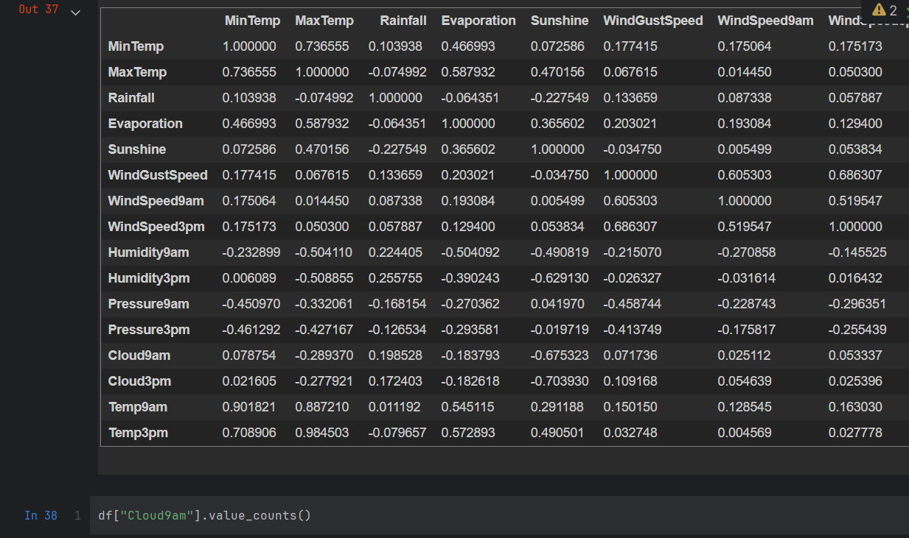

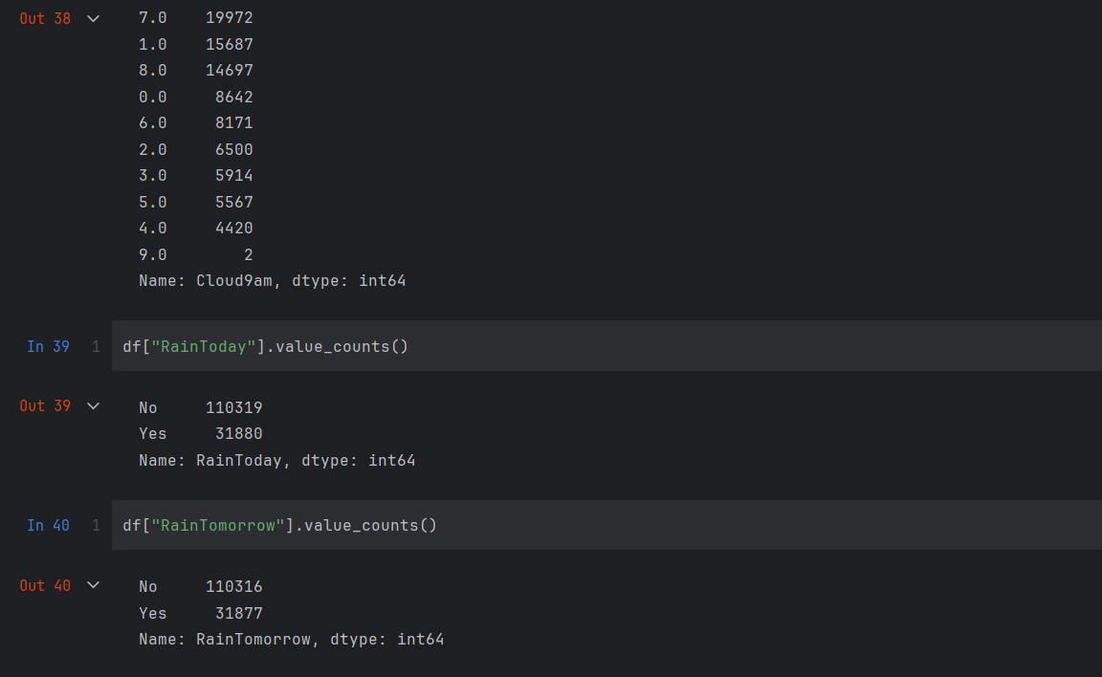

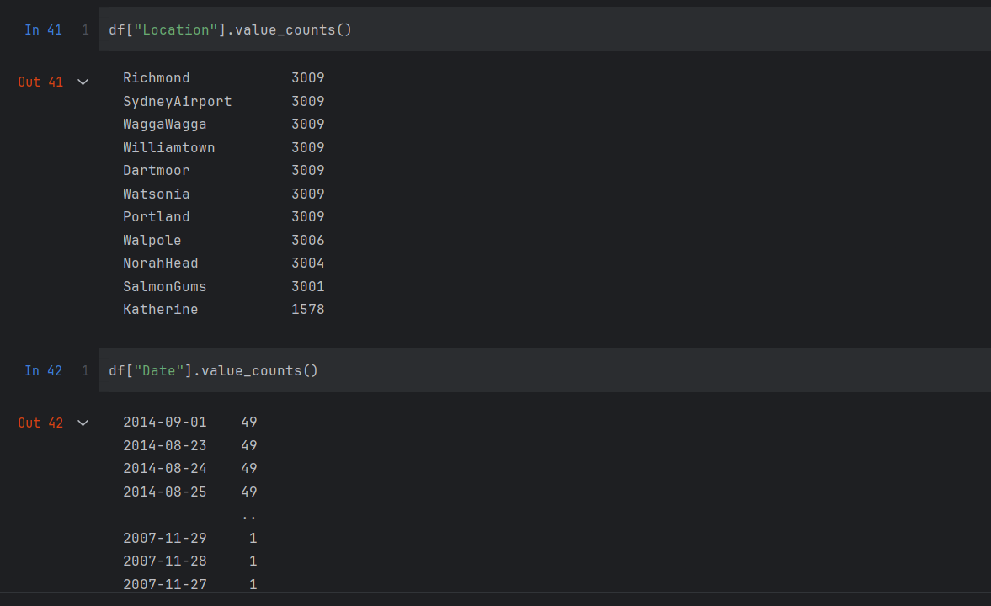

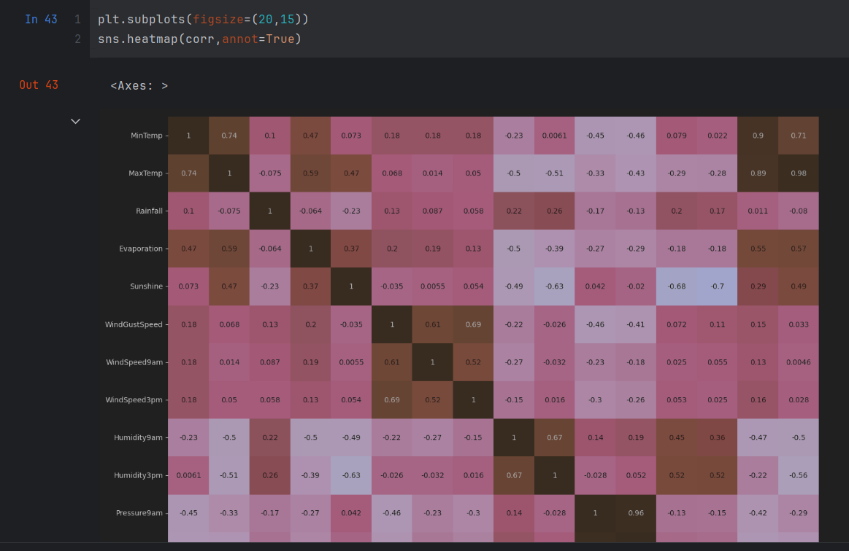

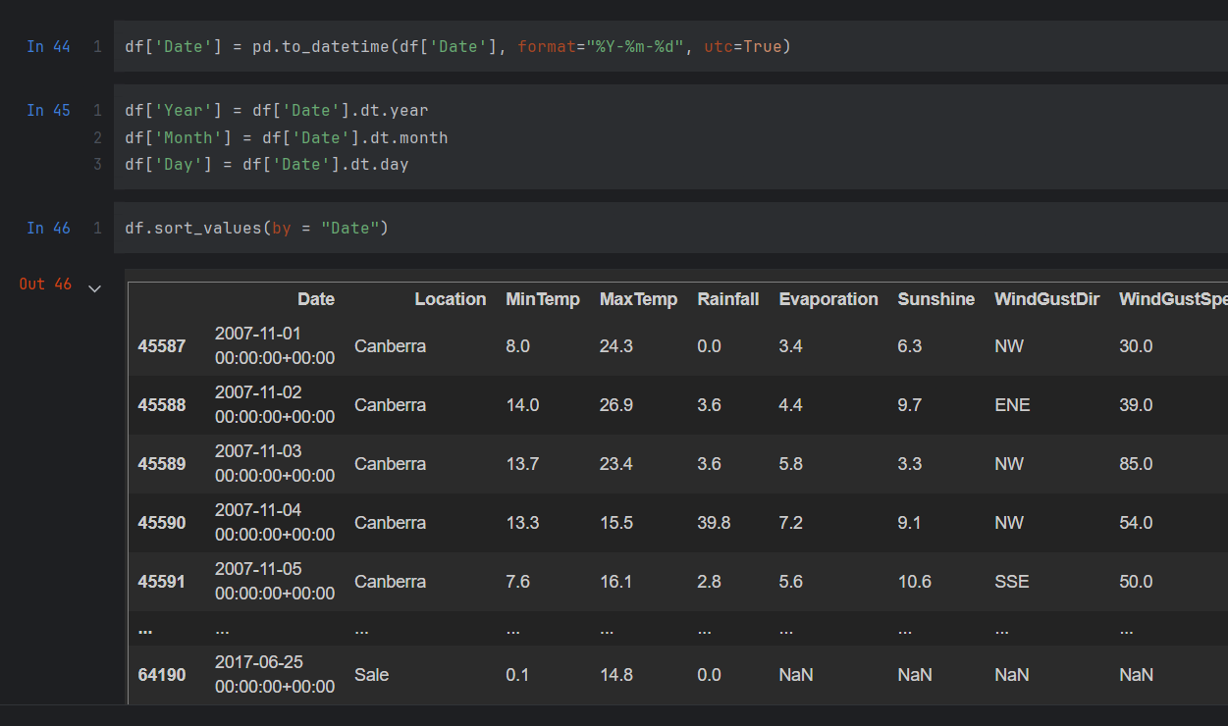

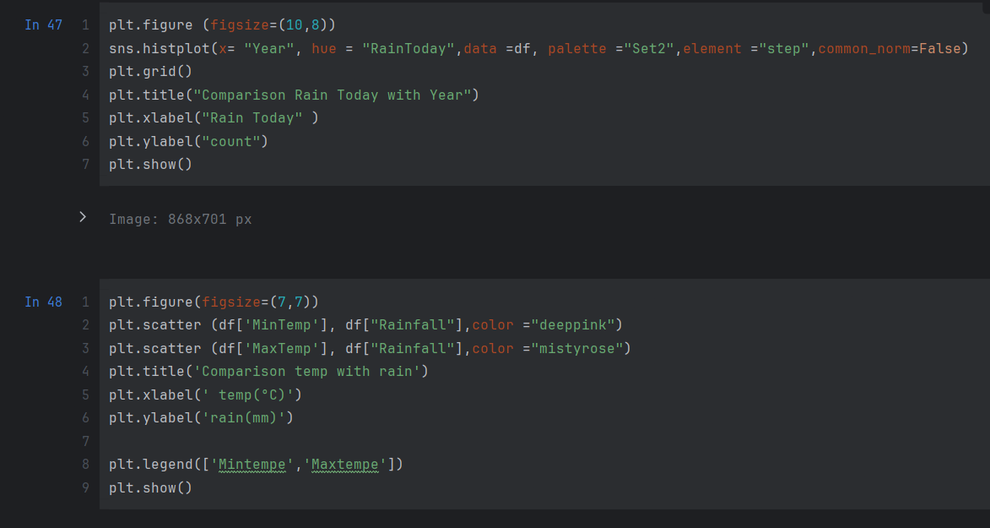

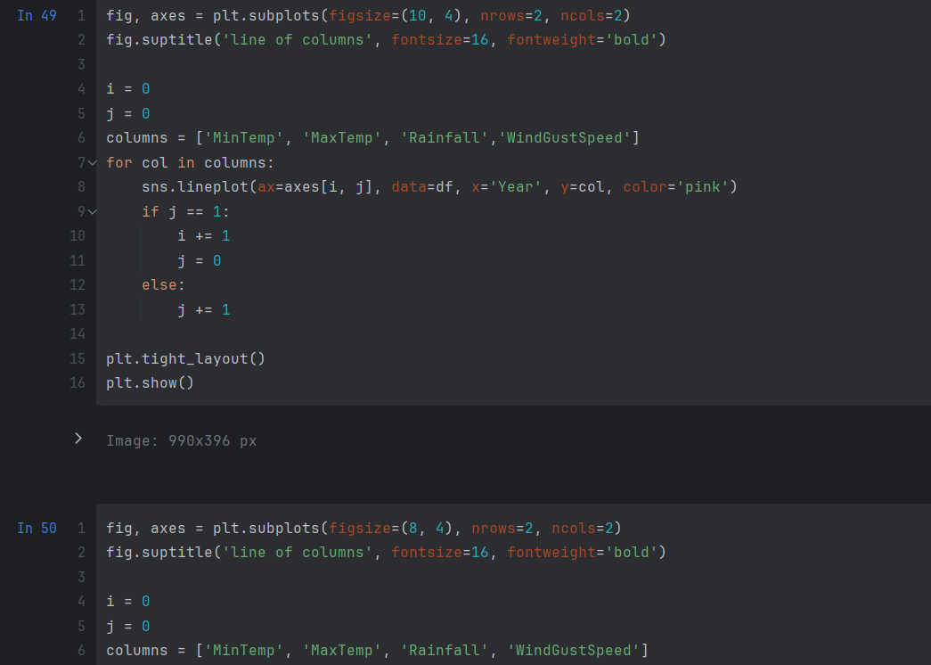

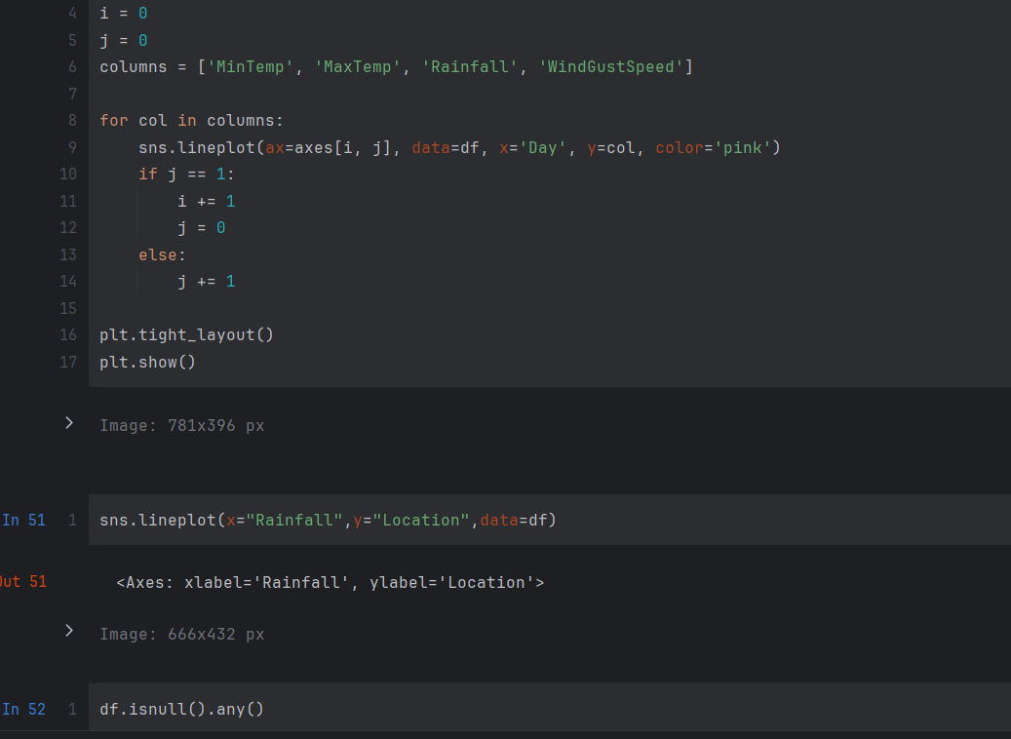

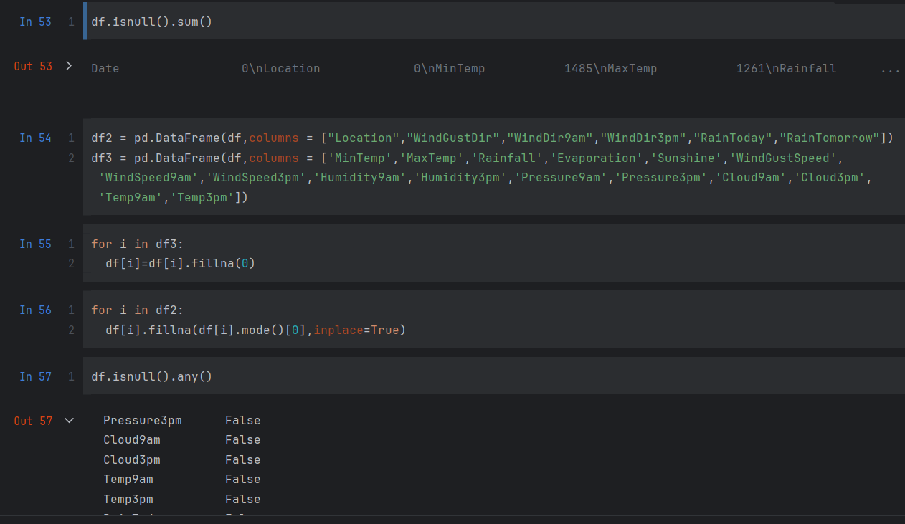

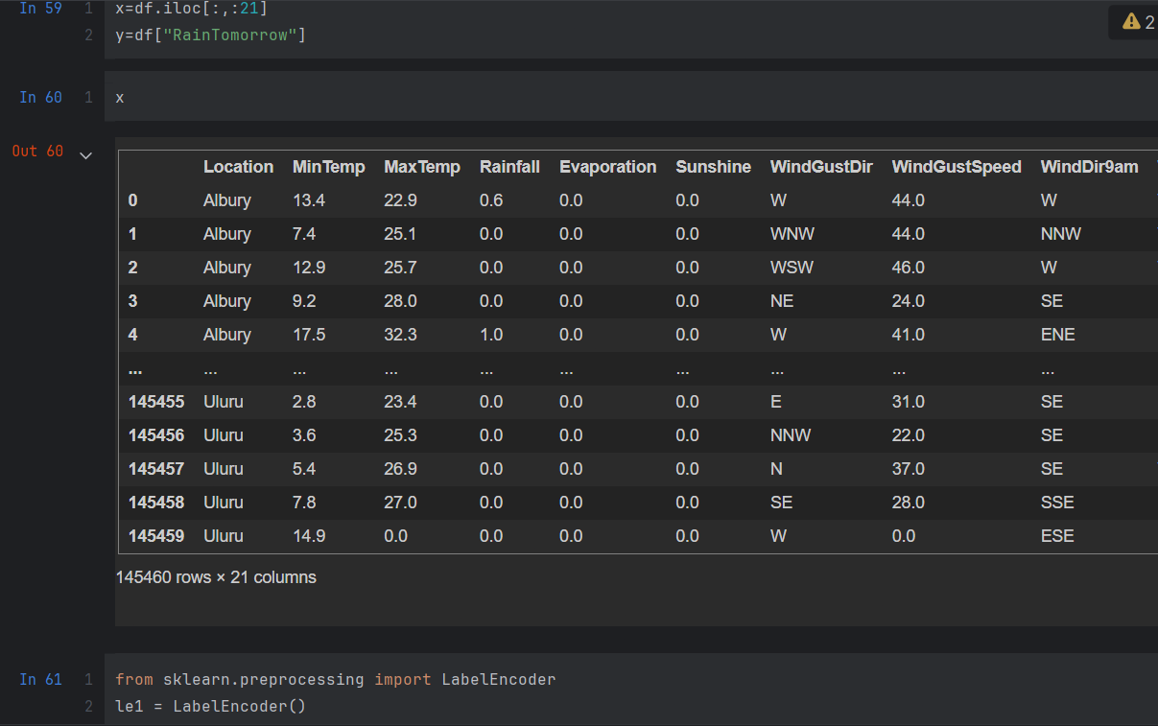

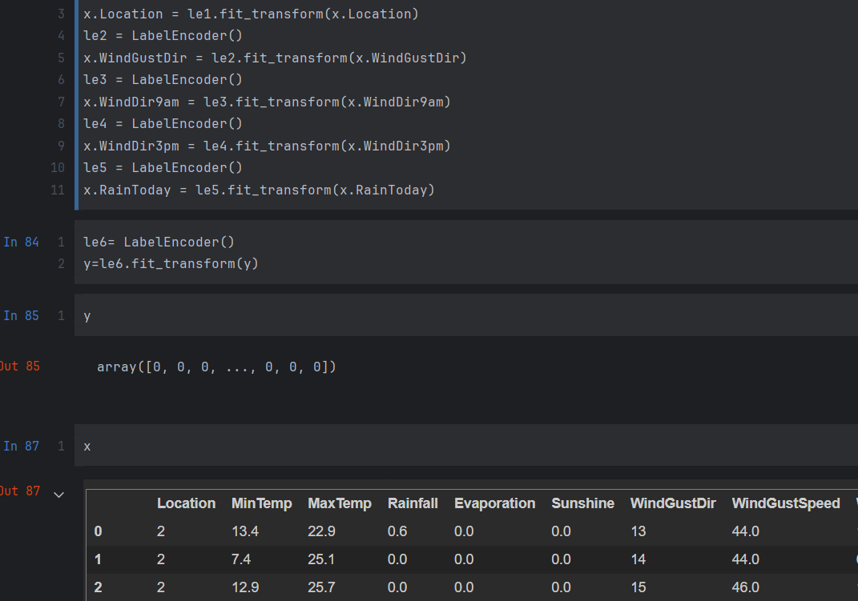

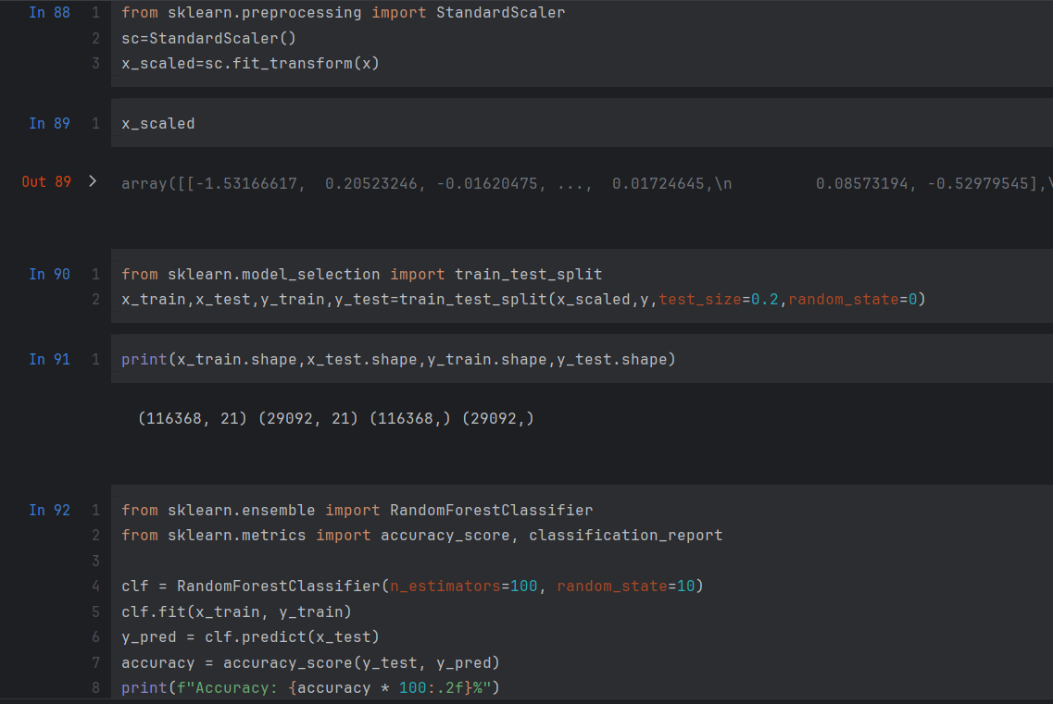

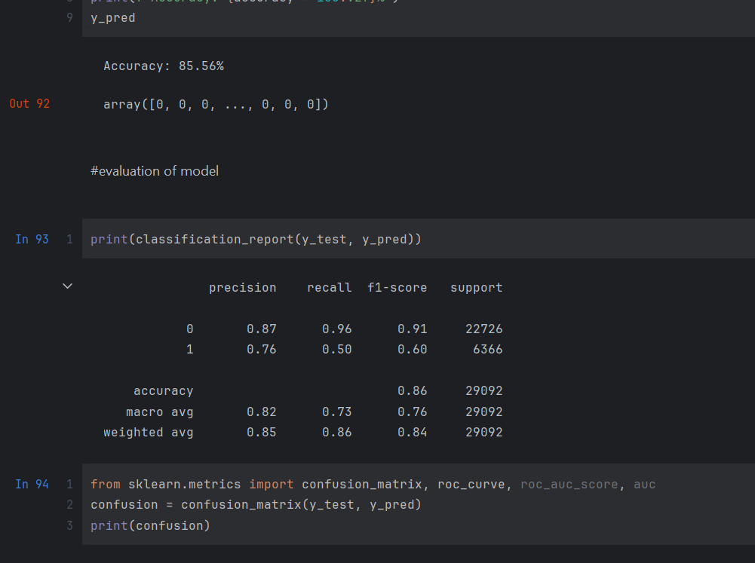

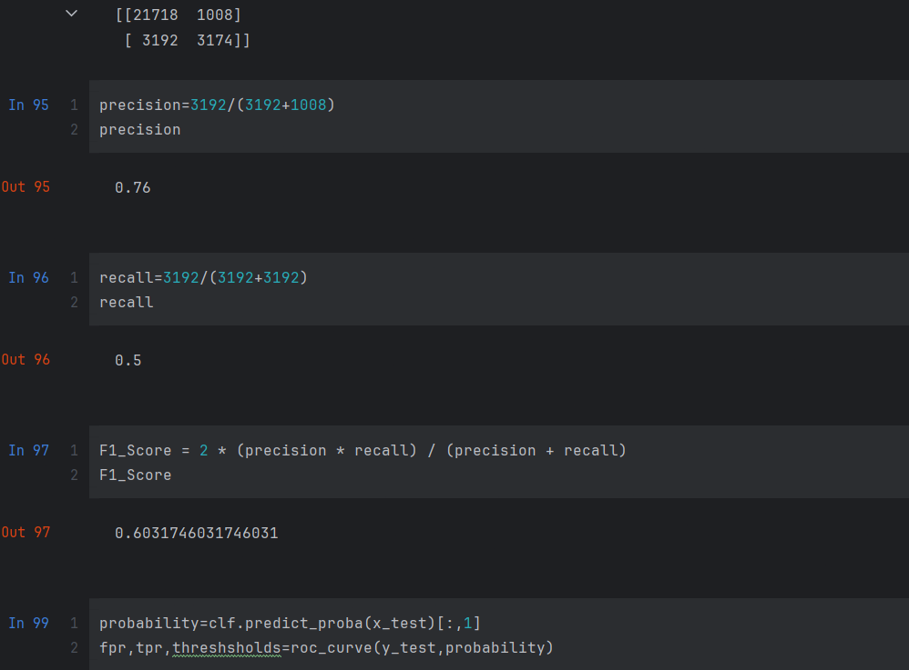

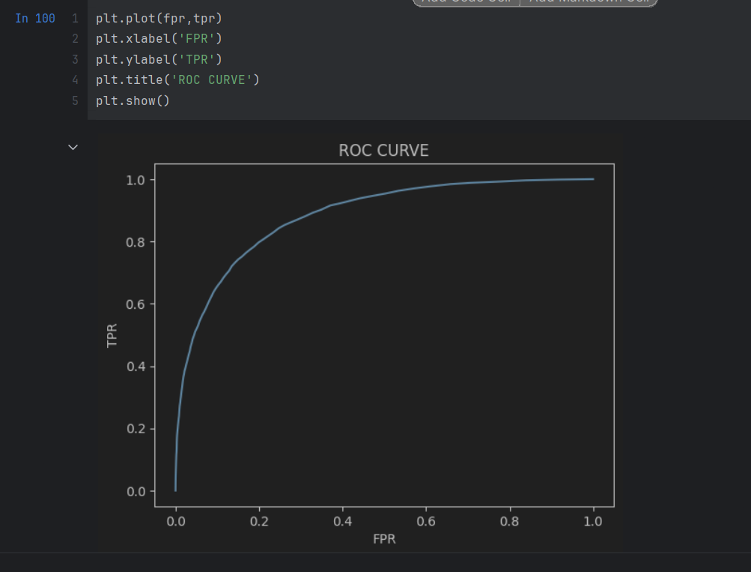

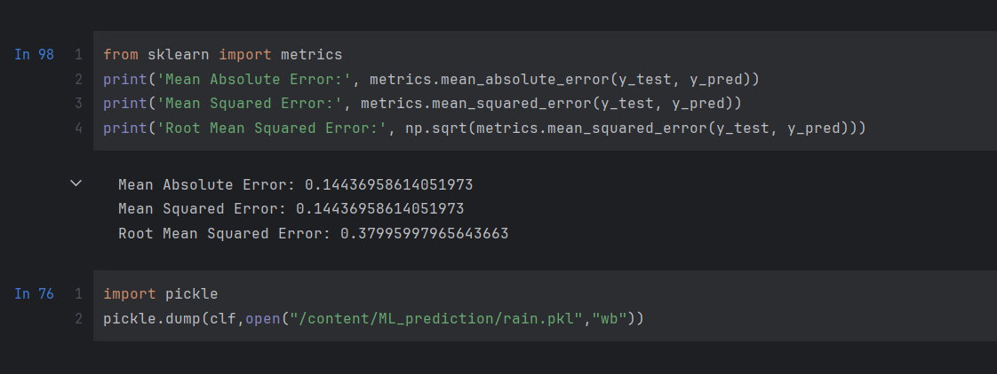

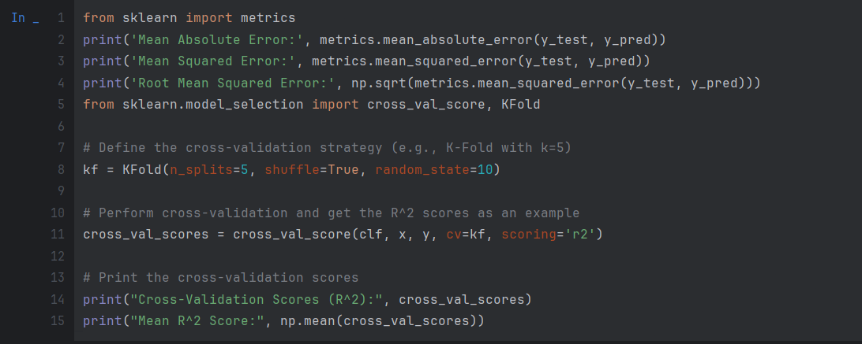

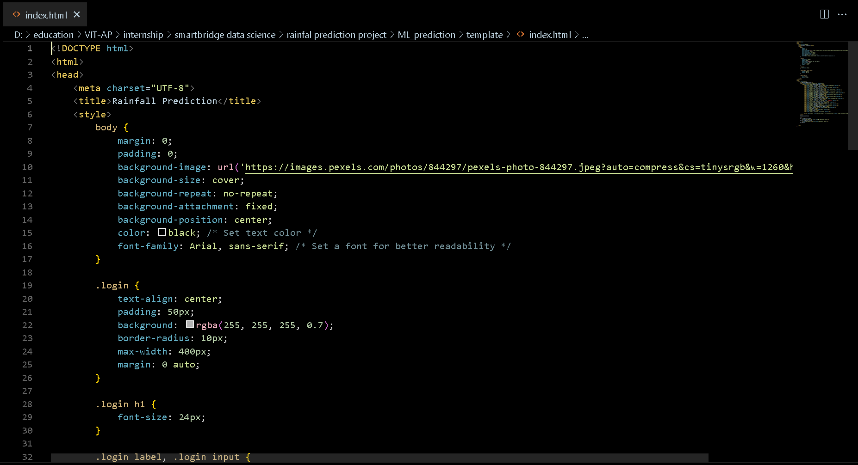

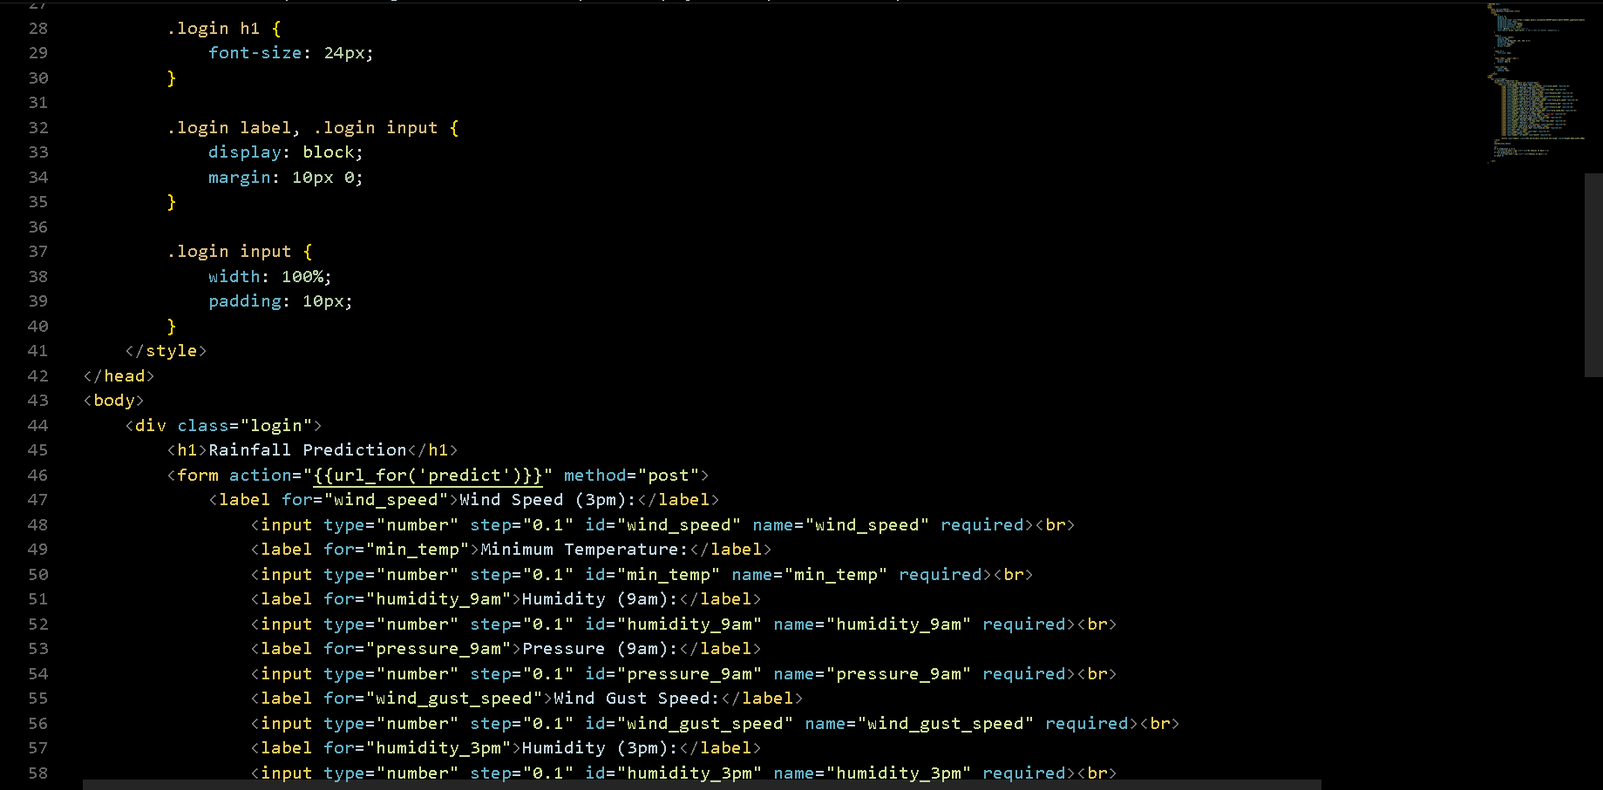

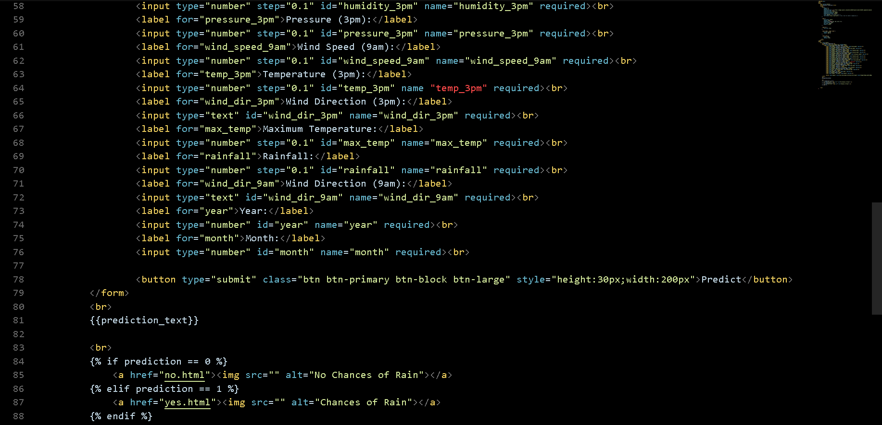



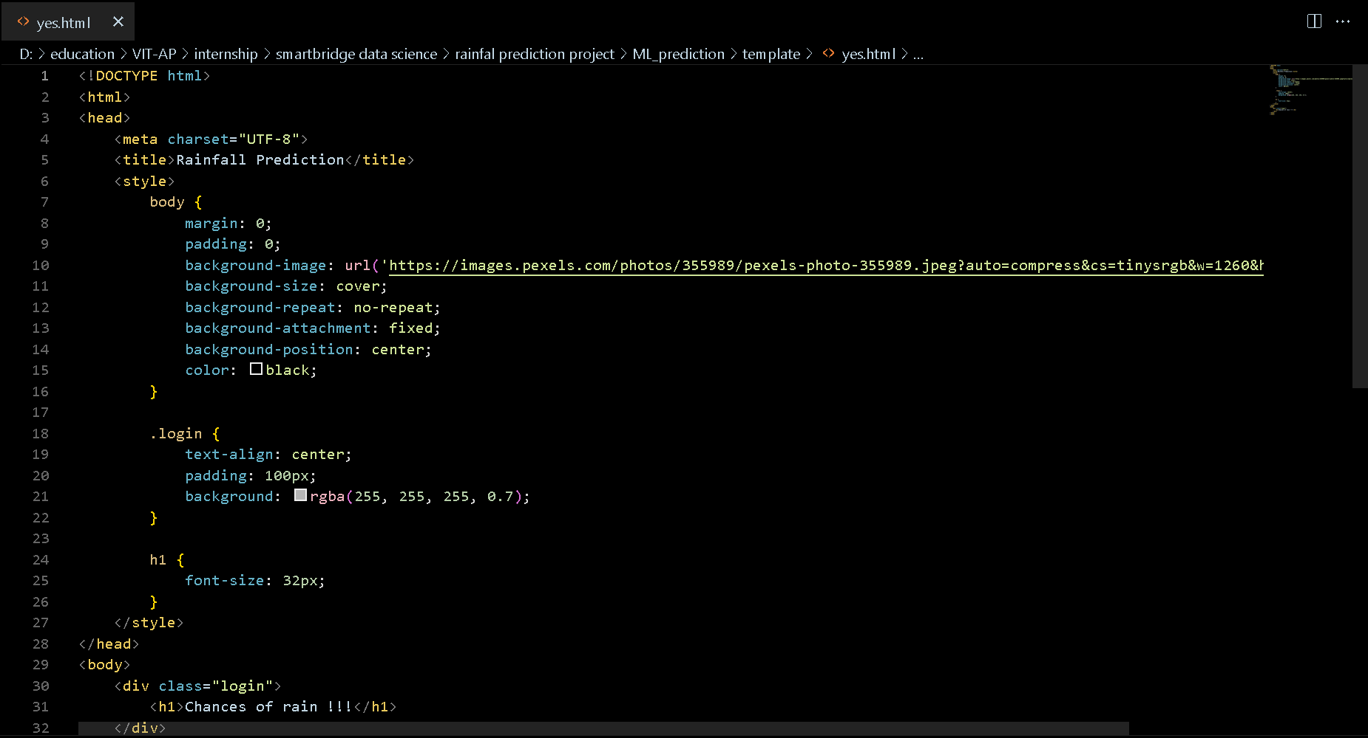



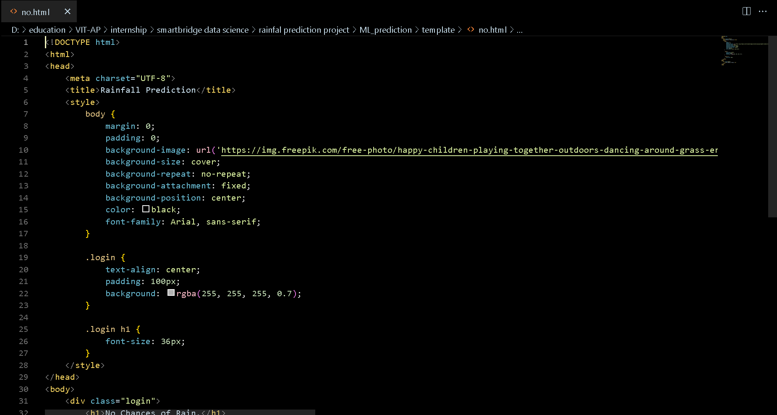

GitHub & Project Demo Link

<https://github.com/smartinternz02/SI-GuidedProject-593759-1697265734>

Project demo link: [http://127.0.0.1:5000/](undefined)